Envol Vert

Press Release Paris, 7th December 2015
Under embargo until 8th December 2015

France must not lend its support to the destructive project for a Canal in Nicaragua!

Nicaragua came under scrutiny during the COP 21 for its refusal to make its commitment to reducing national greenhouse gas emissions, as well as for its plans to build a new inter-oceanic canal which would be destructive both in terms of the local environment and the significant contribution which it would make to greenhouse gas emissions. While French representatives have, one the one hand, stepped up to manage the negotiations between nations in the hope of limiting the rise in global temperature, they have also announced that they see the opportunity for French businesses to play a positive part in this project – one which contravenes the terms of numerous international agreements! Envol Vert is demanding that French representatives end their complicity with actions leading to the destruction of planet, instead announcing the nation’s official opposition to this project so that it may be cancelled before works are due to commence in 2016.

The climatically, socially and environmentally disastrous implications of this project

The Chinese group HKND has received planning permission from the Nicaraguan government for the construction and management for the next 50 years of an inter-oceanic canal. The canal would be the biggest of its kind ever to be built: cutting across the south of the country, it would be 280 km long, 230 metres wide and almost 30 metres deep. Experts working at the International Board of Environmental Resources Management (ERM), charged with looking into the potential social and environmental consequences of the project, have found that the project of building the canal could release more than an estimated 33,000 billions of tons of C02 (including the emissions involved in its running costs), as well as around 50,000 billion tons of greenhouse gasses coming from water traffic. These estimations have not even considered the loss of biomass, the impact of other directly linked projects such as the construction of new airports or water plants, or indirect consequences such as the displacement of local communities and the potential deforestation of natural reserve areas or degradation of protected tropical regions.

The region which would be affected is rich in areas of high conservational importance, which would be either directly or indirectly impacted by the project. Among the biggest environmental concerns are: the degradation of protected parks during the imposed displacement of local communities; the complete disruption of the ecosystem in Lake Cocibolca (the largest lake in Central America) as it is made 17 metres deeper; the contamination of water in lakes and community wells as seawater is brought inland; the sapping of astronomical amounts of water resources; the excavation of 5 billion metres cubed of earth.

10 municipalities, 282 towns and villages will be affected, 24,100 families will be forced to move elsewhere and a total of 120 000 people will be directly impacted. The law does not even include any provision or expectation that HKND will have to compensate those adversely affected by the project.

Attempts at International Agreements have come to nothing

According to the environmental organization Centro Humboldt, the law which has granted HKND permission for the construction and management of the canal contravenes at least 10 treaties or international agreements relating to the environment. Numerous local orgnisations of varying concerns (social, environmental, security…) have argued that this law is unconstitutional, and they have lodged over 100 appeals with the Supreme Court, all of which have been dismissed. ERM has also highlighted the failure to conduct 7 key investigations, and has found 21 breaches of the rules of International Financial Cooperation (IFC), which the project fails to address. The report finds that ‘the project will have unavoidable consequences’ and that ‘the planned excavation of certain areas and the forced displacement of communities does not comply with international codes’. Finally, the report argues that the proposed path which the canal will follow is not in fact viable, and will lead to an eventual loss in profits.

France is seeking to be complicit in this outrage!

Upon taking up his post as French ambassador to Nicaragua in October 2015, Frédéric Besaguren declared that French businesses in the construction sector might be able to take part in this mammoth project. The diplomat reported to the President of the French National Assembly, Iris Montenegro, that ‘It would be a very good thing if those overseeing the construction of the inter-oceanic canal were to establish links with businesses in France’. Daisy Tarrier, the president of Envol Vert, meanwhile, is of the opinion that: ‘It was sheer lunacy for the Ambassador to state that it would be a good move for French businesses to back a project with such destructive implications for the environment and welfare, especially during the COP21, when we are meant to be proving France’s dedication to enabling heads of states to find solutions to environmental concerns!’.

The French organization Envol Vert is calling upon the French government to withdraw its support

Envol Vert is an NGO founded in partnership with the Fundación del Rio in 2013, and we have been working ever since to protect the area of the Reserva Indio Maiz from environmental degradation by leading sylvopastoralism and reforestation projects in co-operation with local communities. It is this area which will be affected by the canal, and the local community who we work with are, therefore, very concerned about the potential consequences of the project. Envol Vert wholeheartedly condemns the Nicaraguan government’s decision, as well as the position which French delegates have taken, and we are speaking out on behalf of the Nicaraguan people with the single purpose of putting a stop to this project’s development.
Envol Vert has launched a petition which will be sent both to the French government and the French Ambassador in Nicaragua, requesting that the Ambassador shows France’s official stance to be of firm opposition to the project, and that he ensures no French businesses, nor financial support from France will be -directly or indirectly- involved in the project.
Sign the petition here: https://www.change.org/p/frédéric-basaguren-emmanuel-macron-laurent-fabius- canal-du-nicaragua-pour-que-la-france-ne-soit-pas-complice-stopcomplicecanalnicaragua #StopCompliceCanalNicaragua

Envol Vert is an association for the protection of the forest and biodiversity working to reconnect people with their natural environment and help local communities to establish a way of life which causes less damage to surroundings whilst creating a more secure, sustainable source of income and resources. These core values mean that we focus on supporting small, local initiatives in France and Latin America: establishing primary forest nature reserves, carrying out scientific studies, proposing solutions to deforestation and overseeing reforestation work. Our guiding motto , ‘The forest helps us so let’s help it’, brings together individuals and businesses who have been inspired to support this worthy cause. http://envol-vert.org/ - http://www.facebook.com/EnvolVert - http://www.youtube.com/user/envolvert

La Fundación del Rio (The River Foundation) is an NGO which has been working for over 25 years to support conservation and sustainable development in South East Nicaragua. The foundation was one of the main drivers of the RAMSAR declaration for the protection of the region’s tropical zones, and they have since been working to create a protected nature reserve in Indio Maíz. La Fundación del Río is a member of the Grupo Cocibolca, a platform of independent organizations who have been studying the potential ramifications of the Nicaraguan canal project, as well as offering expert advice for the last 7 years in climate change negotiations. www.fundaciondelrio.org - www.fundaciondelrio.blogspot.com - www.salvemoslareservaindiomaiz.org

Press contacts:
Daisy Tarrier, President and founder of Envol Vert: +33 6 03 28 58 01, dtarrier@envol-vert.org
Amaru Ruíz Aleman, President of La Fundación del Río, amaruiz18@yahoo.es

The Canal’s path and its impact

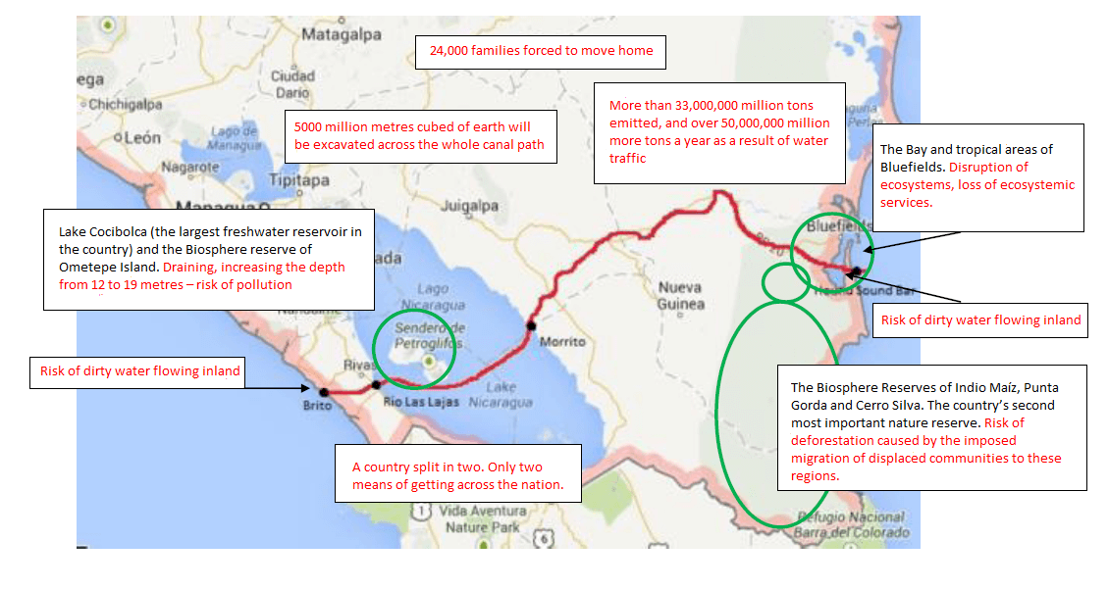

1 http://qz.com/430090/why-is-a-chinese-tycoon-building-a-50-billion-canal-in-nicaragua-that-no-one-wants/ http://hknd-group.com/portal.php?mod=list&catid=46
2 http://hknd-group.com/portal.php?mod=view&aid=294
Volumen 3, Capitulo 6-7. Titulo 6.6.3 et Volumen 3, Capitulo 6-7, Tabla 6.6-4
Topographie, Evaluation géothermique et risque sismique, drainage acide de roches, étude de sédimentation du lac du Nicaragua, Balance hydrique et Risque de salinité, archéologie subaquatique.
http://www.ifc.org/wps/wcm/connect/55d37e804a5b586a908b9f8969adcc27/PS_Spanish_2012_Full-Document.pdf?MOD=AJPERES
6 http://www.elnuevodiario.com.ni/politica/372643-francia-ve-positivo-participar-construccion-canal/

